

Date: 01 July 2022

# Subject: Project Acceptance Certificate

TO WHOMSOEVER IT MAY CONCERN

This is to certify that **Ms Monica R (REG NO: C21101PCA6210)** of **MCA - Computer Application**, **Institute of Distance Education University of Madras** has accepted her final year project work from **01stJuly 2022 to 31 st December 2022.**

The project was undertaken by her in “**Airline reservation system “**

**DOMAIN:** Java

# Thank you for engaging KKR INFOTECH

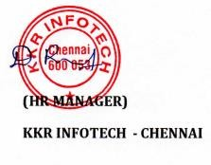

Address: 5/19, Pandiyan Complex, 1st Floor Prithivipakkam Main Road, Ambattur, Chennai – 600 053 Mail Id: [info@kkrinfotech.co.in](mailto:info@kkrinfotech.co.in) Website: [www.kkrinfotech.co.in](http://www.kkrinfotech.co.in/)

Phone:: +91-044-49578931